Lambing is here, so here is a reminder of some points to note.
Pre-lambing nutrition:
There is no time of year that ewe nutrition is more important than at lambing time. Poor energy and protein content of a diet has a direct correlation with function of the immune system so there is a higher incidence of all diseases in ewes that are on a poor diet. At lambing time, this could correspond to mastitis, increased worm egg output, and conditions such as hypocalcaemia and pregnancy toxaemia. This immune suppression can transfer to lambs due to poor quality and quantity of colostrum , leading to poor growth rates and increased risk of neonatal disease in the lambs.
When looking at nutrition don’t forget to check how the diet is presented – this can be just as important as what is in the feed itself. Start by checking the following: Is there enough feed space so all ewes can access concentrates and forage at one time. Are younger ewes being bullied away from the feed, is there any spoilage of the diet? (try to avoid feeding on the ground, or where it might get wet.), If they are getting a TMR (mixed ration), are the sheep prone to sorting through and only eating some of it?
Scanning data and body condition scoring can help separate ewes out depending on their individual feed requirements. It is important to remember that it can take 6 – 8 weeks for a ewe to gain one body condition score on good grazing so changes where necessary need to be done well in advance of the critical times (tupping and lambing). The ideal body condition scores should be between 2-3/5.
Dry matter intake should be equivalent to 2-2.5% of bodyweight during pregnancy. It is essential when formulating a diet to maximise forage intakes of ewes, then supplement with other concentrates only by enough to make up any calculated nutritional deficit.

Vaginal prolapse in ewes
Usually about 1% of a flock would be expected to prolapse. It generally occurs during the last 4 weeks of pregnancy. The bladder often becomes obstructed, the prolapsed tissue is easily infected and in the worst cases, the ewe will continue to strain so much that the tissue becomes torn, or ripped and intestines prolapse out. These cases are invariably fatal, though if close enough to term, occasionally the lambs can be saved.
There are many causes of vaginal prolapses, however none of them are proven. They include bulky feed, high-fibre diets, lack of exercise, housing, grazing on steep slopes, subclinical hypocalcaemia, big lambs or large numbers of lambs and animals that are too fat at lambing. It is known that about 40% of affected ewes will prolapse again in later pregnancies, so it is advised that problem sheep should be culled before the next season.
There are various ways to fix the prolapse back in place, using sutures, paddles or harnesses. Pain-relief and antibiotics are important too. The affected ewes will be at increased risk of problems lambing so once the prolapsed is fixed they should be kept under close observation. In particular, affected ewes at lambing can be slow to open up and develop ring womb. In these cases 60 -100ml of calcium under the skin and a wait of half an hour or so may help.
Uterine prolapses, involving the whole womb, after lambing are different - and less likely to recur in subsequent years. These are mostly associated with large single lambs and difficult lambings that have resulted in infection and pain of the reproductive tract, resulting in the ewe continuing to strain after lambing. If caught quickly they can be successfully replaced.

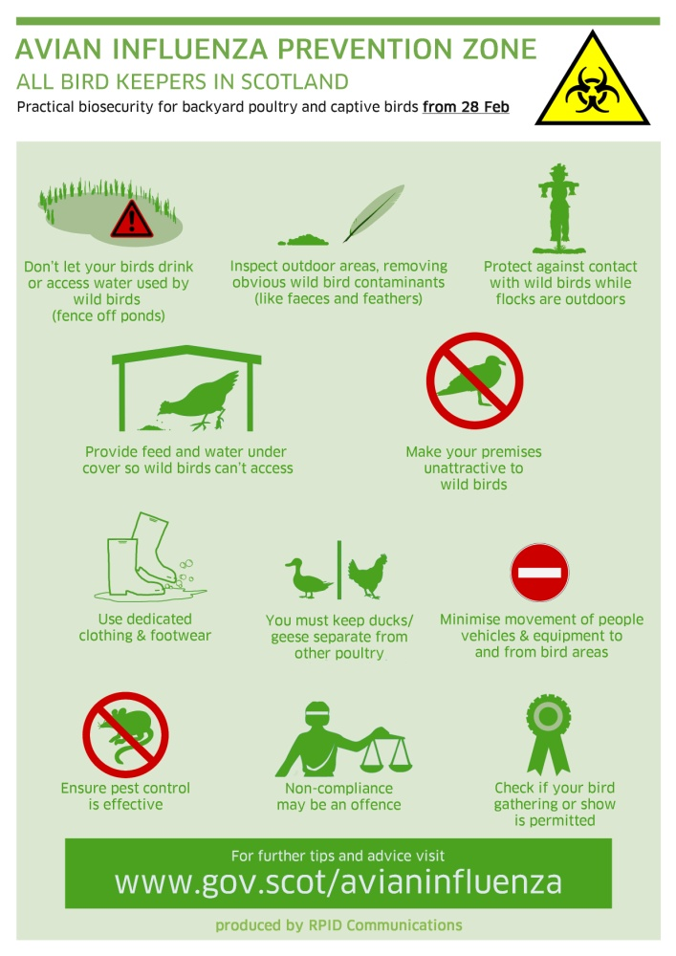Avian Influenza
Finally a brief update on avian influenza: Currently Scotland is within an ‘avian influenza prevention zone’, which will be in place till at least April 30th 2017. This does permit keepers in all of Scotland to let their birds outside provided that they have enhanced biosecurity in place. The biosecurity required is listed in the poster below but for those who require it, there is a lot more information (including the signs to watch out for) at www.gov.scot/avianinfluenza. Where there is a suspicion of the disease (multiple deaths, or a number of sick birds), please get in touch with us for advice.

